Skills Workshop #4: Using Library Facilities at CEAS Library
Title: Seminar on using library facilities at CEAS library
Speakers: Hong Cheng, Global Service Librarian
Mark Chalmers, Science and Engineering Librarian for the UC STEM populations

Date: 14 June 2019

Time: 3:45 – 5:00 pm
Venue: Baldwin Hall, Room 741

Prepared by: Girija Nair-Hart, PhD. Associate Professor of Mathematics, University of Cincinnati Clermont College. RET Participant for Project #4: “Modeling of Signalized Intersection Design and Impacts”

Hong Cheng, who is a global Service Librarian conveyed some key information about conducting article searches. She recommended to limit search for 10 years and then narrowing down the resources to the most relevant ones by using a vertical pyramid format. Using WIKIPEDIA as a starting point, she recommended a variety of scholarly database including GOOGLE SCHOLAR. Ms. Cheng elaborated on how to find reliable research in and beyond the library by informing us of different layers of hidden web such as surface web, deep web, and dark web. She emphasized the proper use of search phrases using Boolean operators such as and as well as or to conduct broad and narrow searches. One of the participants asked about accessing government documents. Ms. Cheng answered that .gov, .edu, .org etc. is the place to find such documents.

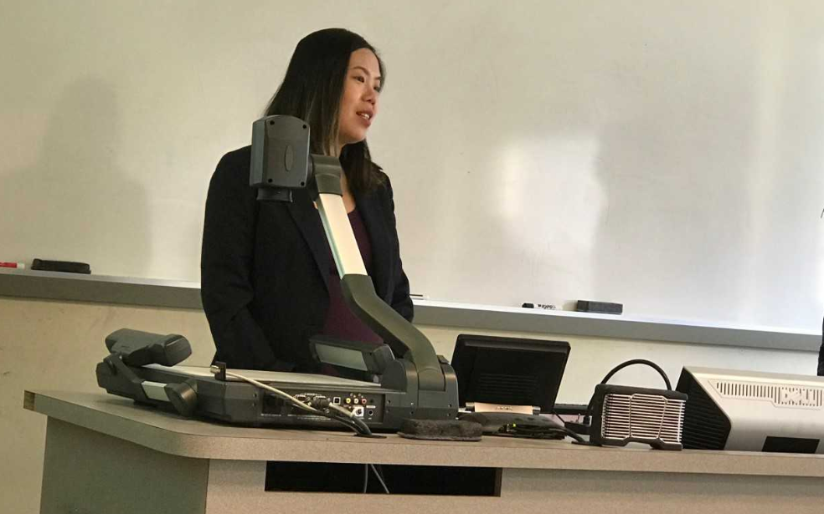
Figure 1: Ms. Cheng Speaking

Mark Chalmers is a science and engineering librarian for the UC STEM populations. His work includes research consultations, teaching and workshops, collection development and liaison responsibilities. Mark also supports new and emerging initiatives such as Research and Data Services, repository outreach and connecting the libraries to UC’s innovation agenda. Mark received his MLIS in May 2018 from Kent State University, and he holds a BA in astrophysics from Ohio Wesleyan University. While at Kent State, Mark worked as a graduate assistant in Dr. Emad Khazraee’s Data Science Research Lab and completed projects in text mining and the analysis of Twitter feed data. While studying for his BA, he was active in undergraduate research, conference presentations and tutoring in physics and astronomy.

Mr. Chalmers talked about UC library system and its 13 libraries with over 800 databases. He also talked about the various advantages of logging on to UC libraries from on campus and off campus. ProQuest and wildcards were also mentioned.

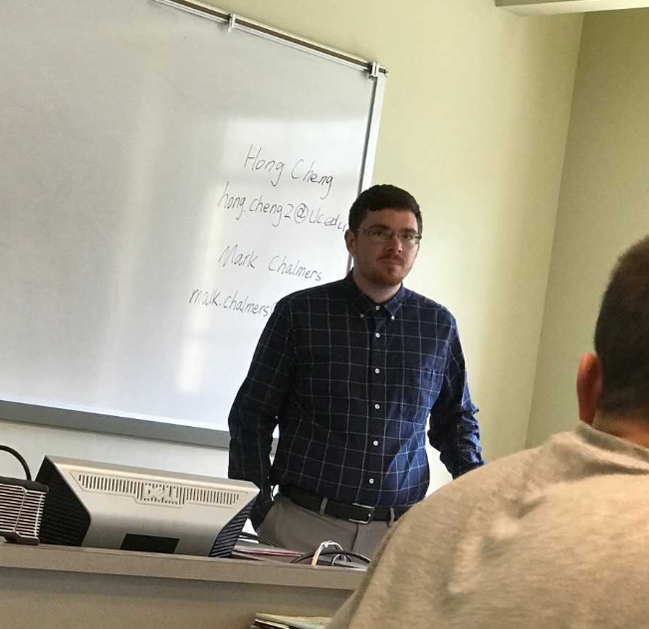
Figure 2: Mr. Chalmers Speaking

